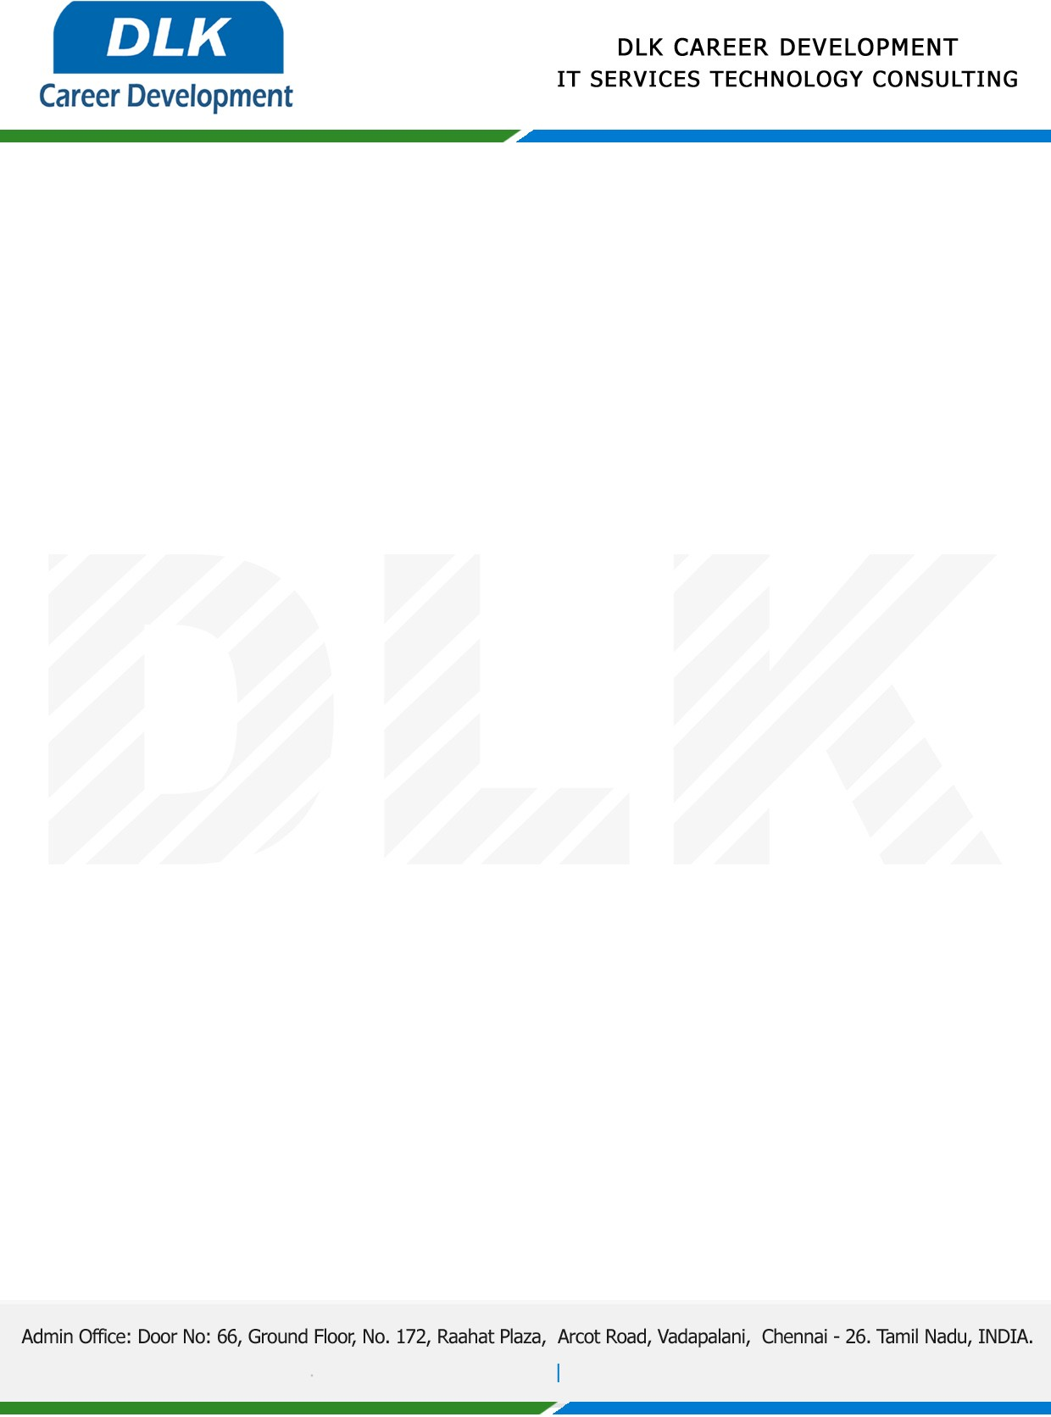

**Date: 17/April /2023**

**SUB: PROJECT COMPLETION CERTIFICATE**

This is to certify that **MS PAPPU VARSHA M (REG NO:** **2113442078012) MSC- Computer Science,** final year student **Justice Basheer Ahamed Sayeed College for Women, Chennai** has Successfully Completed the Project Work under the domain of “**Java”** in our organization during the Period **(28th February 2023 to 12th April 2023).**

**Topic:** Fake Product Identification by QR Code using Blockchain.

We appreciate your interest in **DLK CAREER DEVELOPMENT**

**“Best Wishes for Your Future Endeavors “**

